Inside a Nuclear Power Plant
To build a nuclear reactor, what you need is some mildly enriched uranium. Typically, the uranium is formed into pellets with approximately the same diameter as a dime and a length of an inch or so. The pellets are arranged into long rods, and the rods are collected together into bundles. The bundles are then typically submerged in water inside a pressure vessel. The water acts as a coolant. In order for the reactor to work, the bundle, submerged in water, must be slightly supercritical. That means that, left to its own devices, the uranium would eventually overheat and melt.
To prevent this, control rods made of a material that absorbs neutrons are inserted into the bundle using a mechanism that can raise or lower the control rods. Raising and lowering the control rods allow operators to control the rate of the nuclear reaction. When an operator wants the uranium core to produce more heat, the rods are raised out of the uranium bundle. To create less heat, the rods are lowered into the uranium bundle. The rods can also be lowered completely into the uranium bundle to shut the reactor down in the case of an accident or to change the fuel.
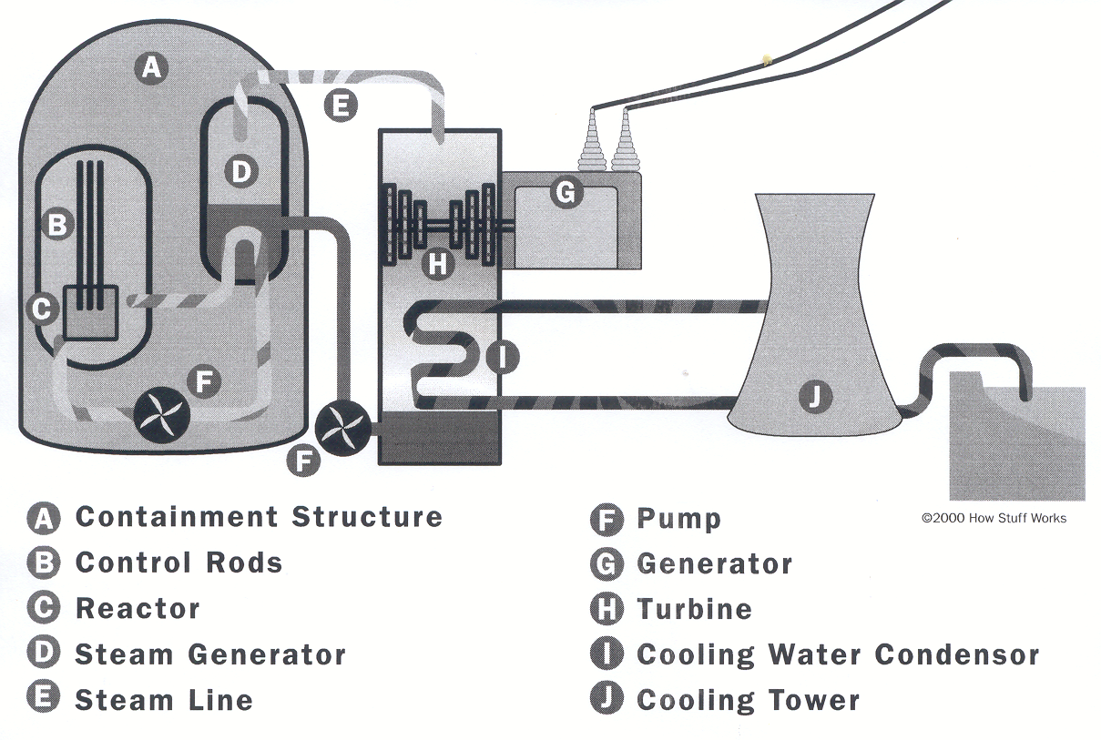
The uranium bundle acts as an extremely high-energy source of heat. It heats the water and turns it to steam. The steam drives a steam turbine, which spins a generator to produce power. In some reactors, the steam from the reactor goes through a secondary, intermediate heat exchanger to convert another loop of water to steam, which drives the turbine. The advantage to this design is that the radioactive water/steam never contacts the turbine. Also, in some reactors, the coolant fluid in contact with the reactor core is gas (carbon dioxide) or liquid metal (sodium, potassium); these types of reactors allow the core to be operated at higher temperatures.

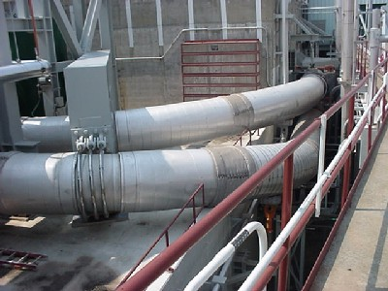
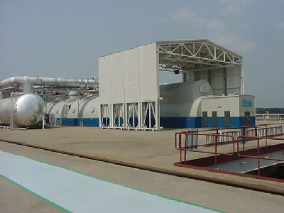
Once you get past the reactor itself, there is very little difference between a nuclear power plant and a coal-fired or oil-fired power plant except for the source of the heat used to create steam.
Electricity for homes and businesses comes from this generator at the Shearon Harris plant. It produces 870 megawatts.

Pipes carry steam to power the generator at the power plant.
The reactor's pressure vessel is typically housed inside a concrete liner that acts as a radiation shield. That liner is housed within a much larger steel containment vessel. This vessel contains the reactor core as well the hardware (cranes, etc.) that allows workers at the plant to refuel and maintain the reactor. The steel containment vessel is intended to prevent leakage of any radioactive gases or fluids from the plant.
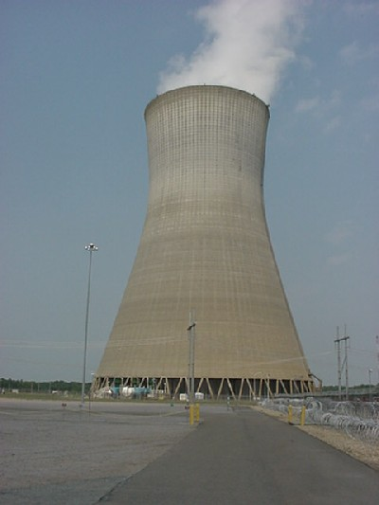
Finally, the containment vessel is protected by an outer concrete building that is strong enough to survive such things as crashing jet airliners. These secondary containment structures are necessary to prevent the escape of radiation/radioactive steam in the event of an accident like the one at Three Mile Island. The absence of secondary containment structures in Russian nuclear power plants allowed radioactive material to escape in an accident at Chernobyl.
Steam rises from the cooling tower at the Harris plant.
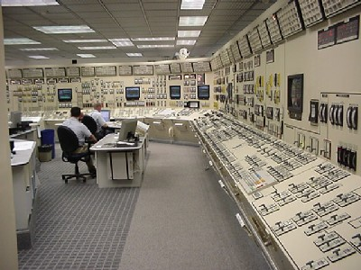
Workers in the control room at the nuclear power plant can keep an eye on the nuclear reactor and take action if something goes wrong.

